Build an event management system using salesfore
- INTRODUCTION

Overview:
Event management is the process of creating and maintaining an event. This process spans from the very beginning of planning all the way to post-event strategizing.
At the start, an event manager makes planning decisions, such as the time, location, and theme of their event. During an event, event managers oversee the event live and makes sure things run smoothly. After an event, event managers are tasked with reviewing event date, submitting KPI and ROI findings, and staying on the ball for any post-event offerings.
All different branches of planning go into event management, including various types of sourcing, designing, regulation checks, and on-site management. In event management, you could be in the process of creating a conference, a product launch, an internal sales kick-off, or even a wedding. Really, any event that requires considerable planning and execution is event managrment.

- PROBLEM DEFINITION AND DESIGN THINKING
EMPATHY MAP:

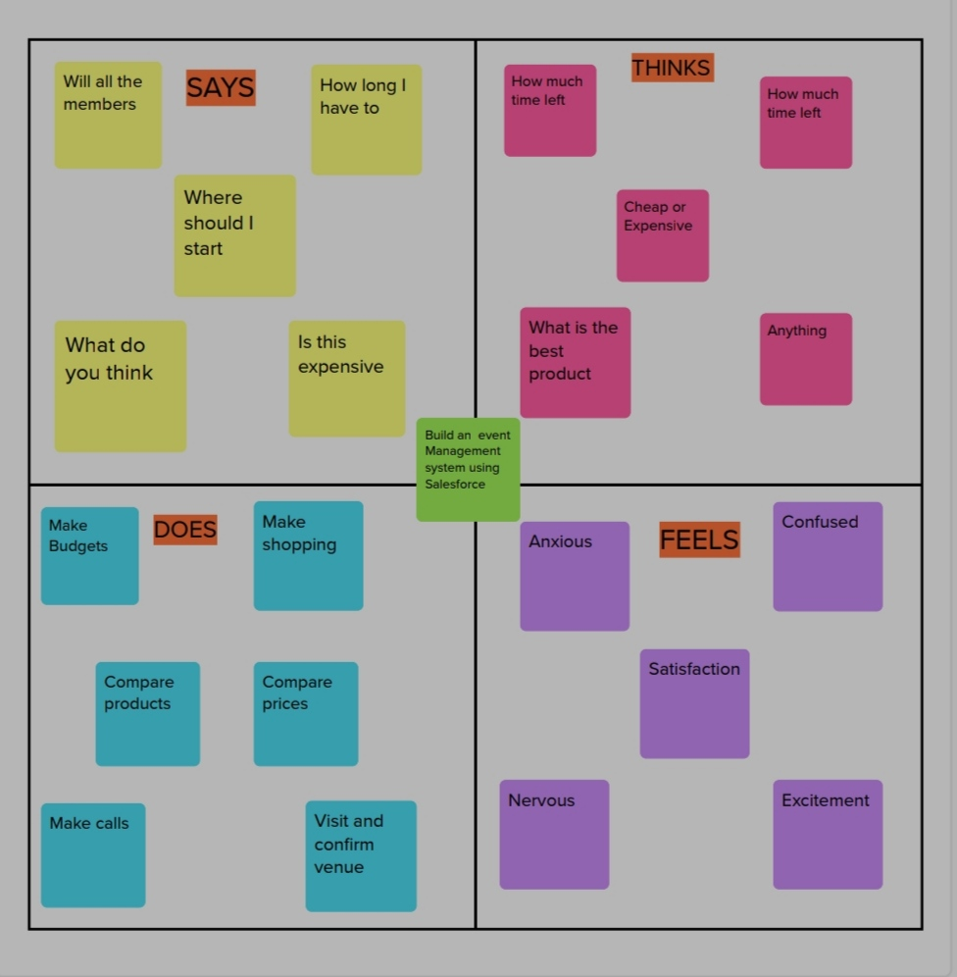
IDEATION AND BRAINSTORMING MAP:

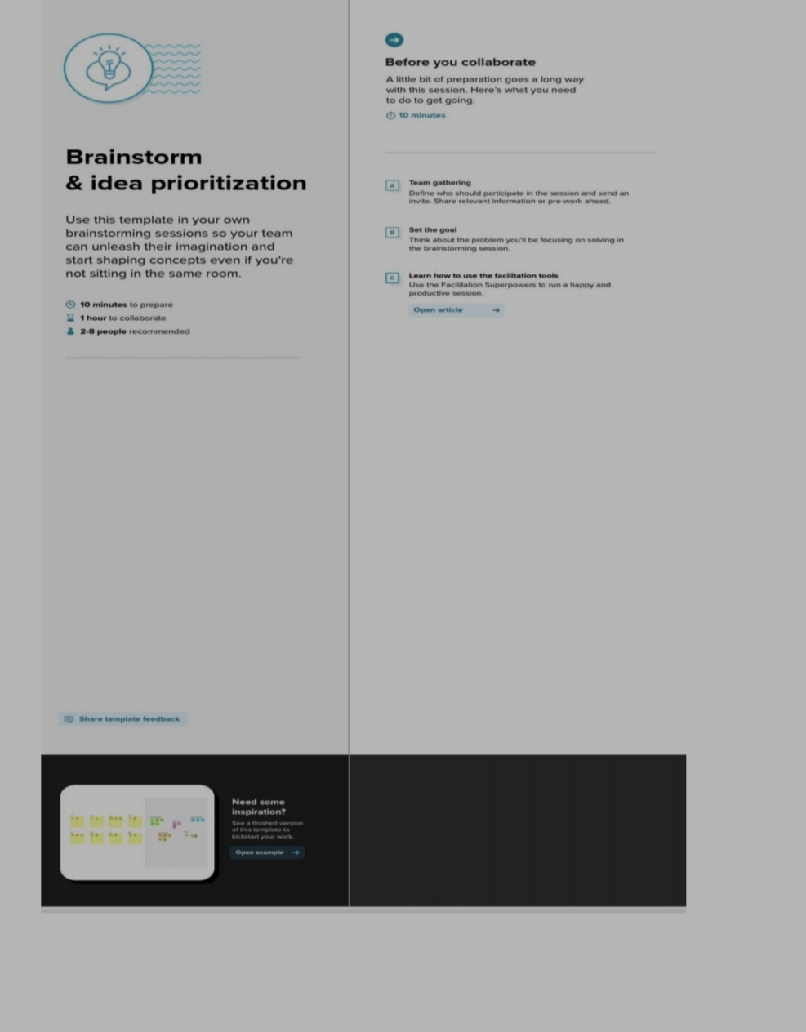
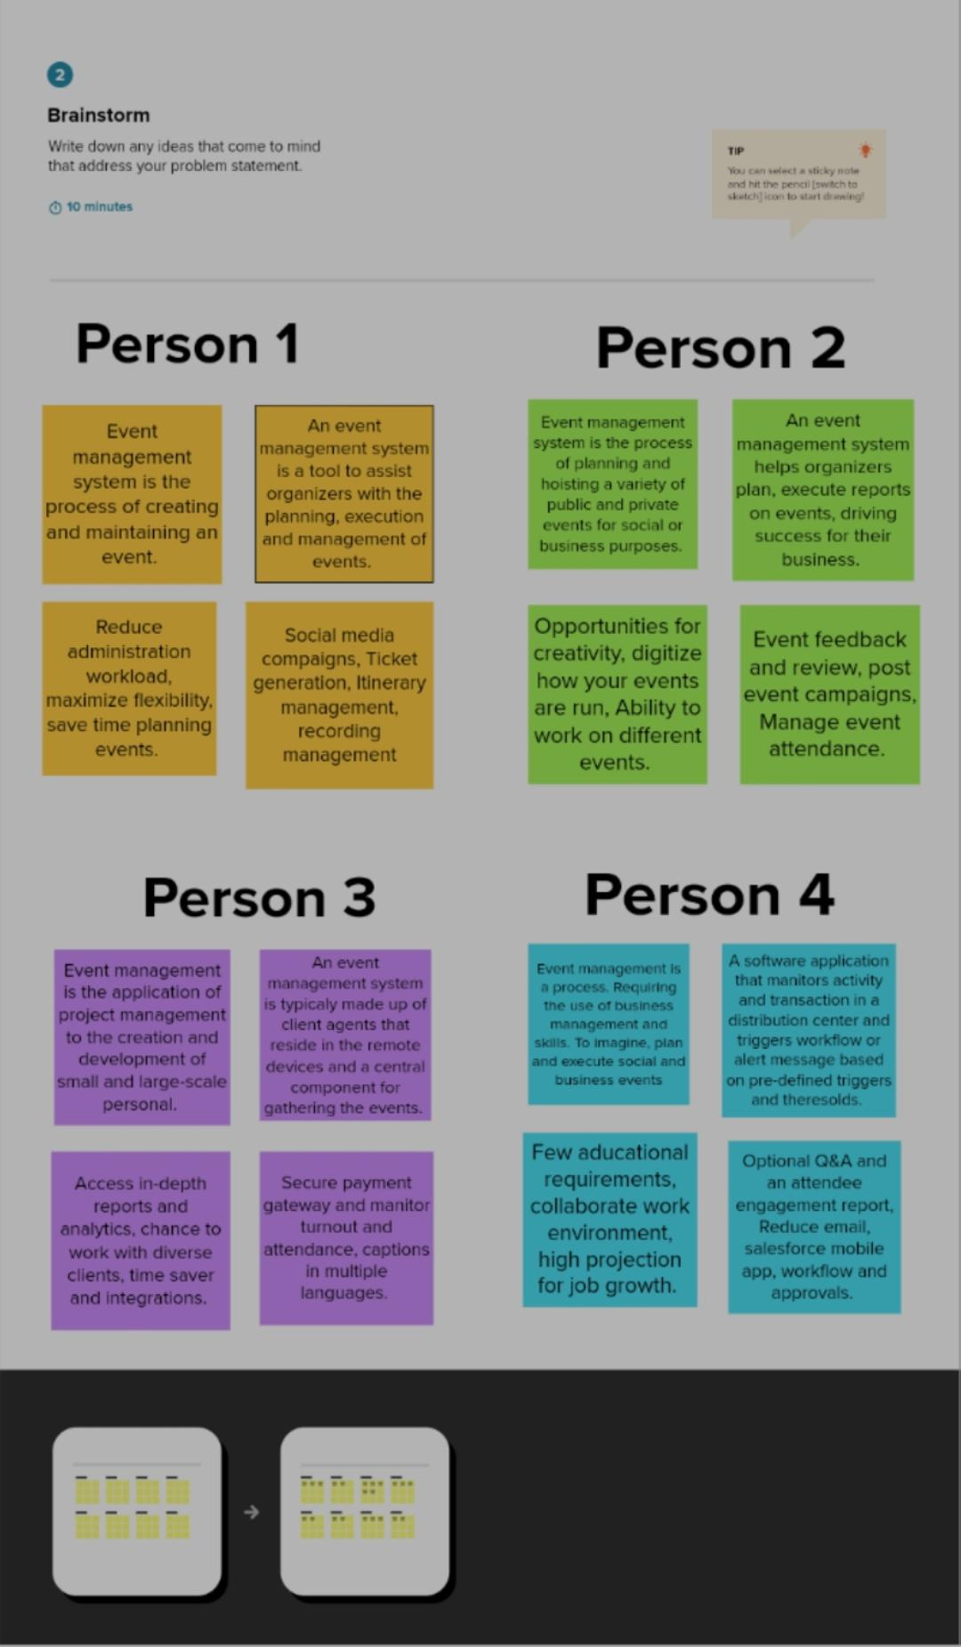
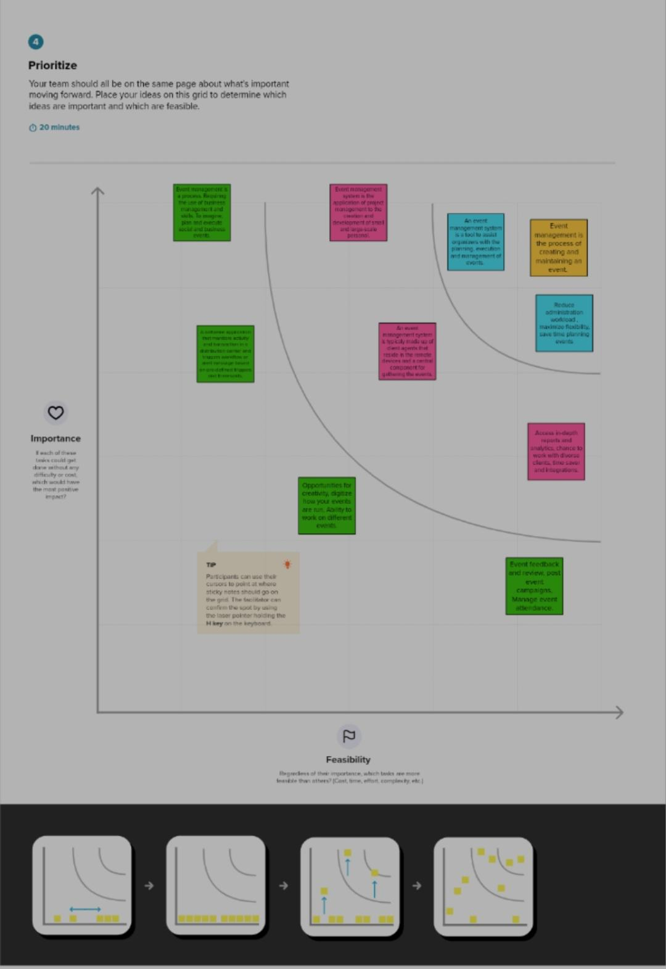

3.RESULTS:
Data madels:-
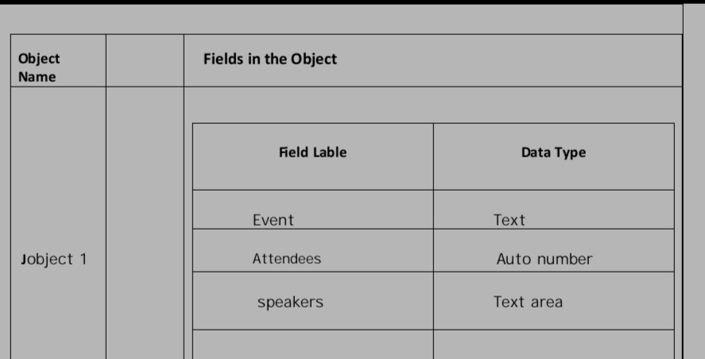
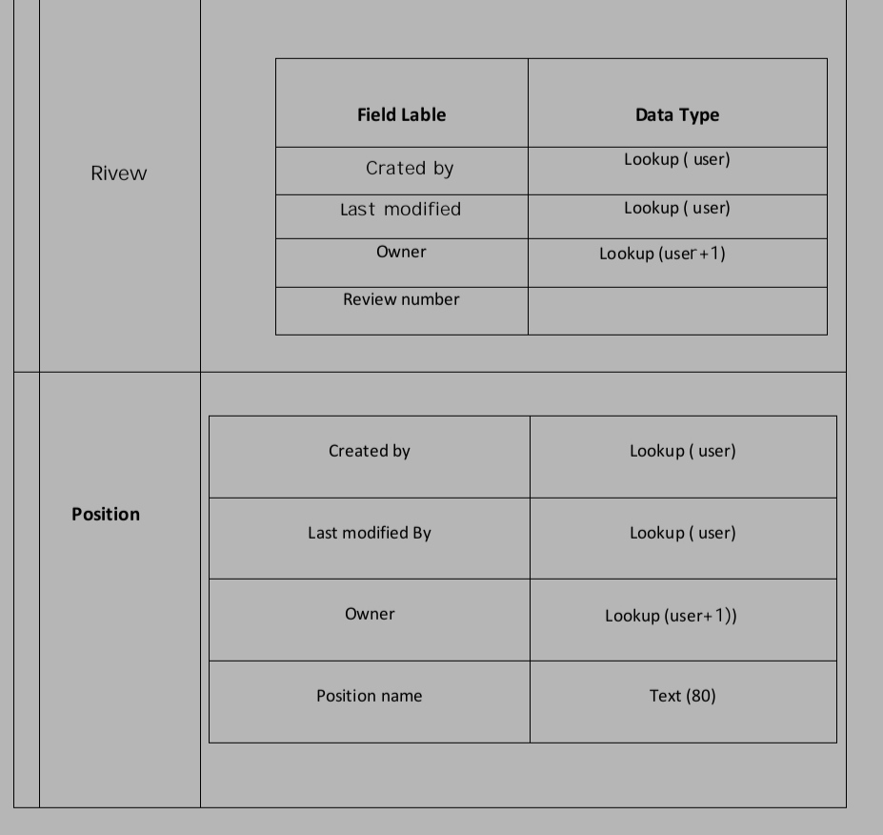
4.ACTIVITY AND SCREENSHOT

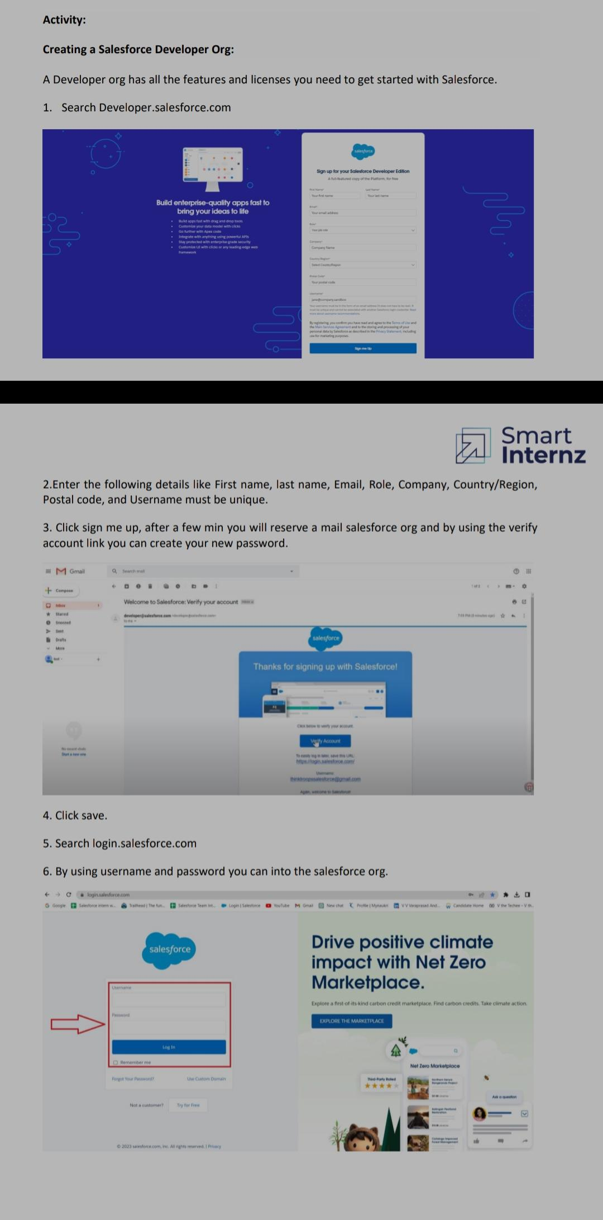
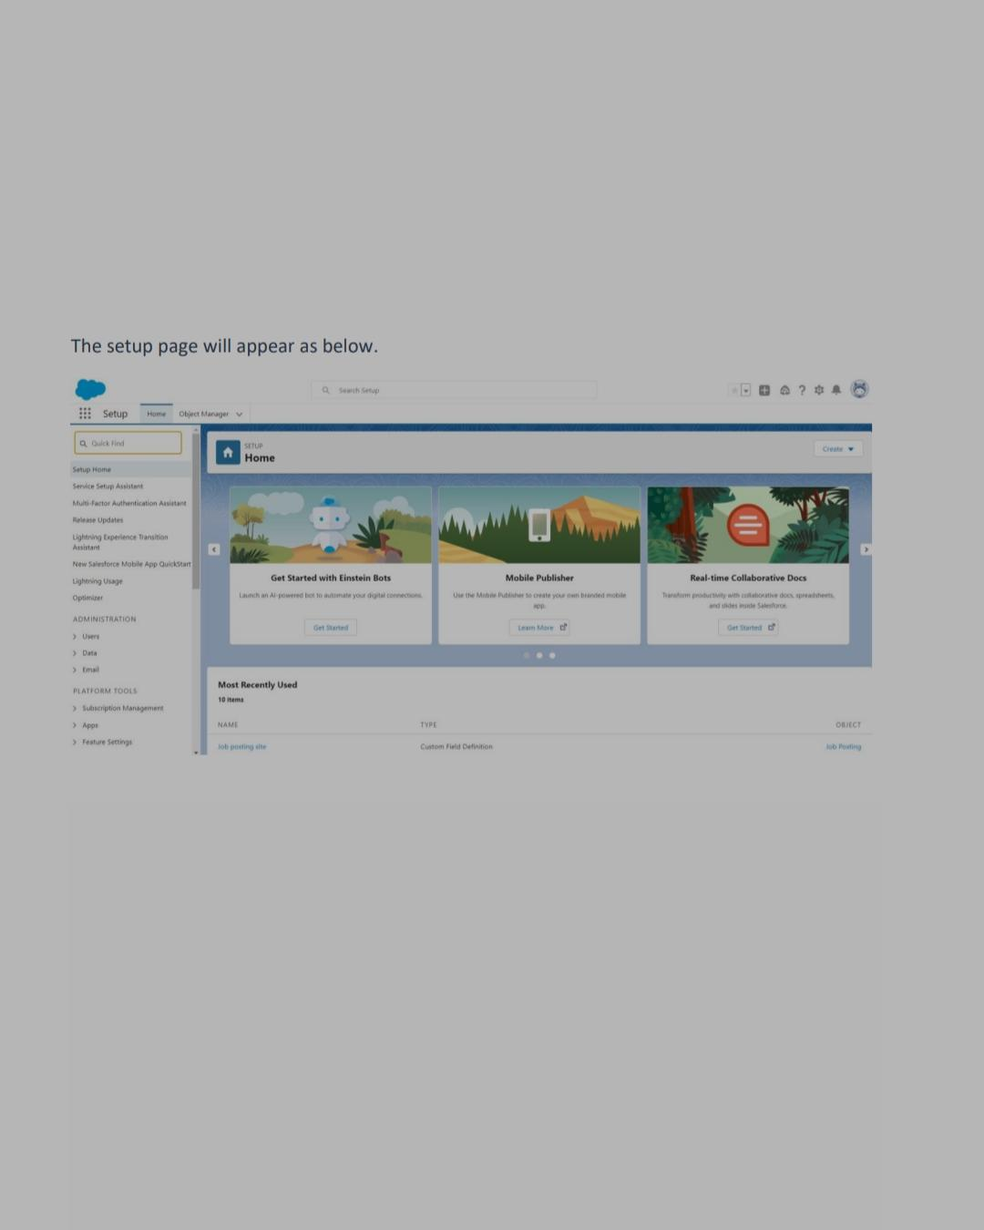

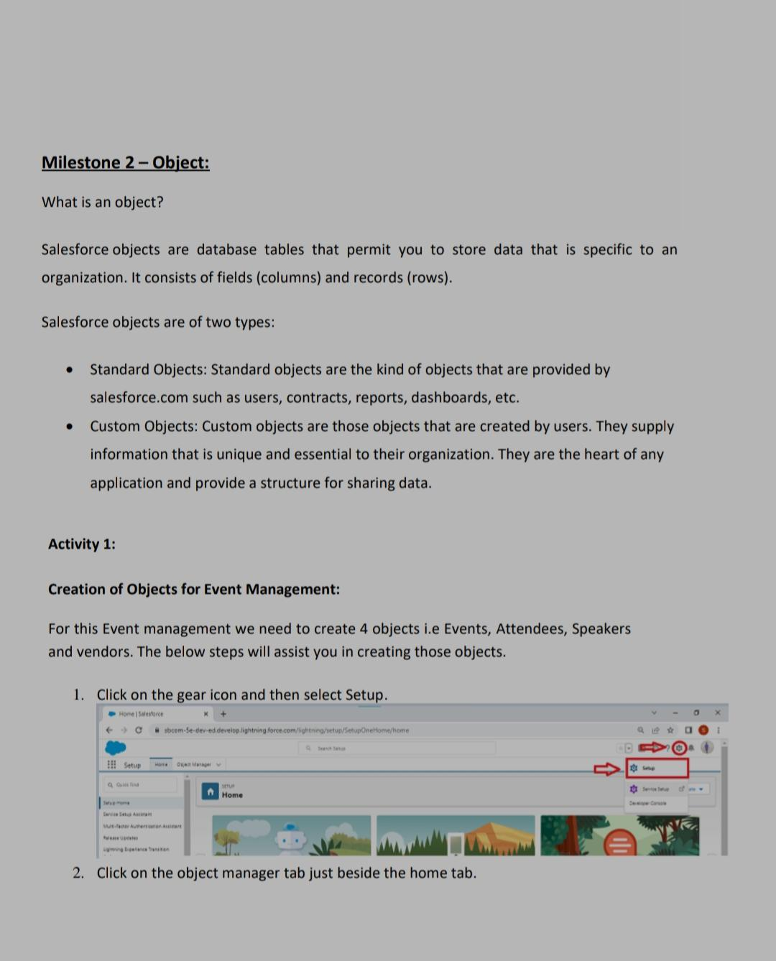
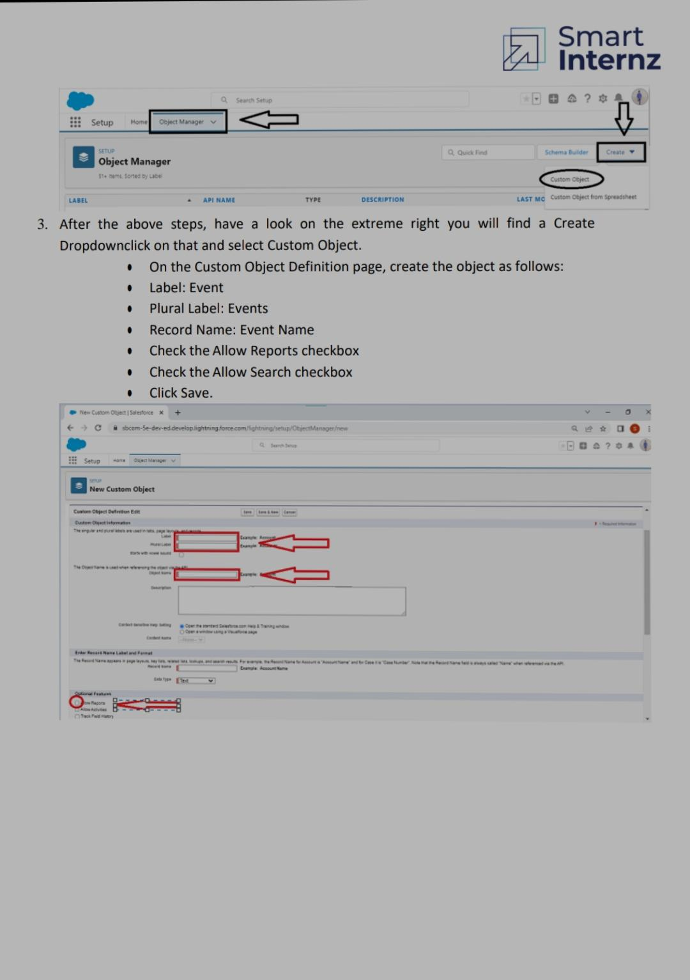
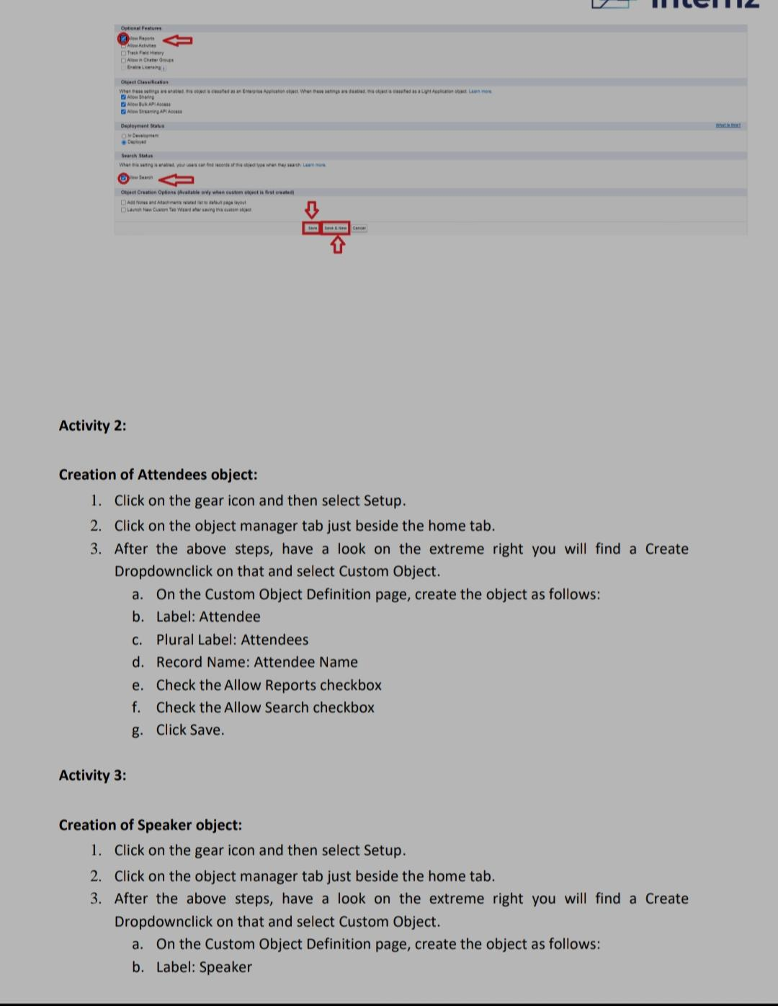
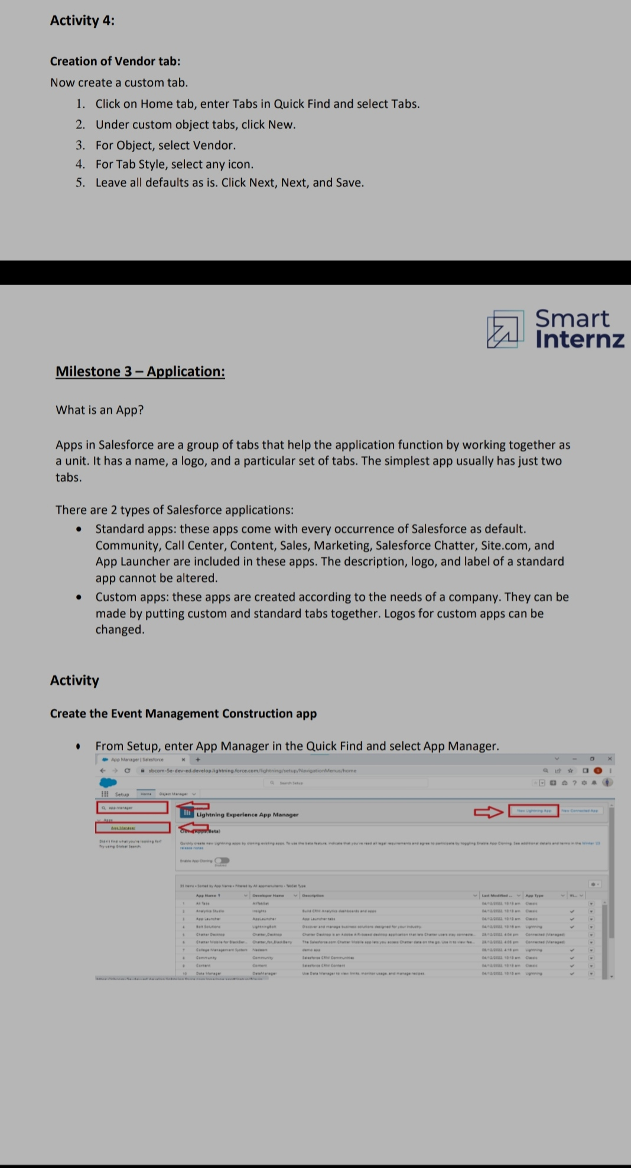
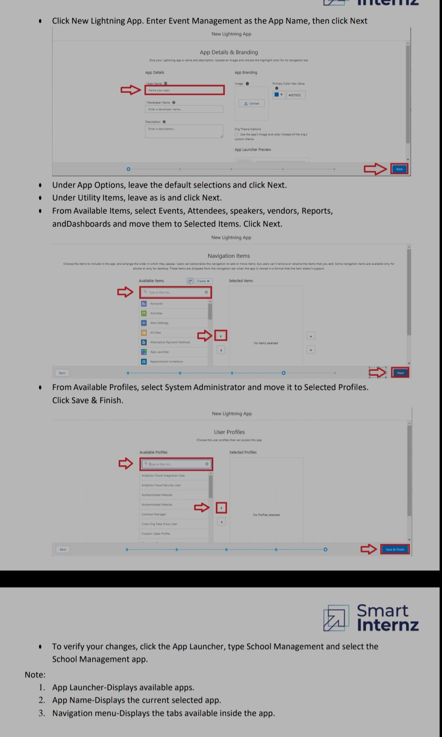

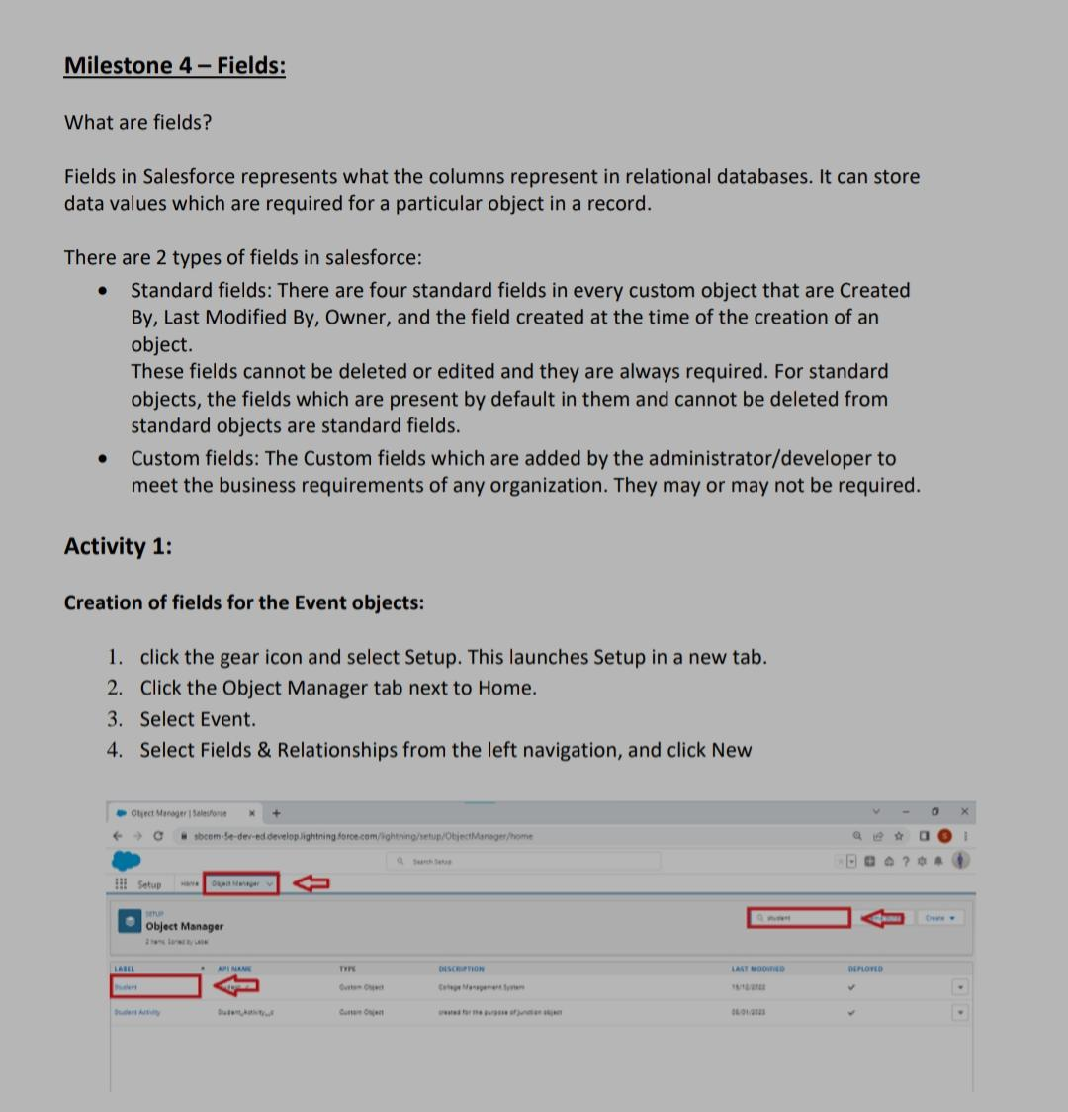
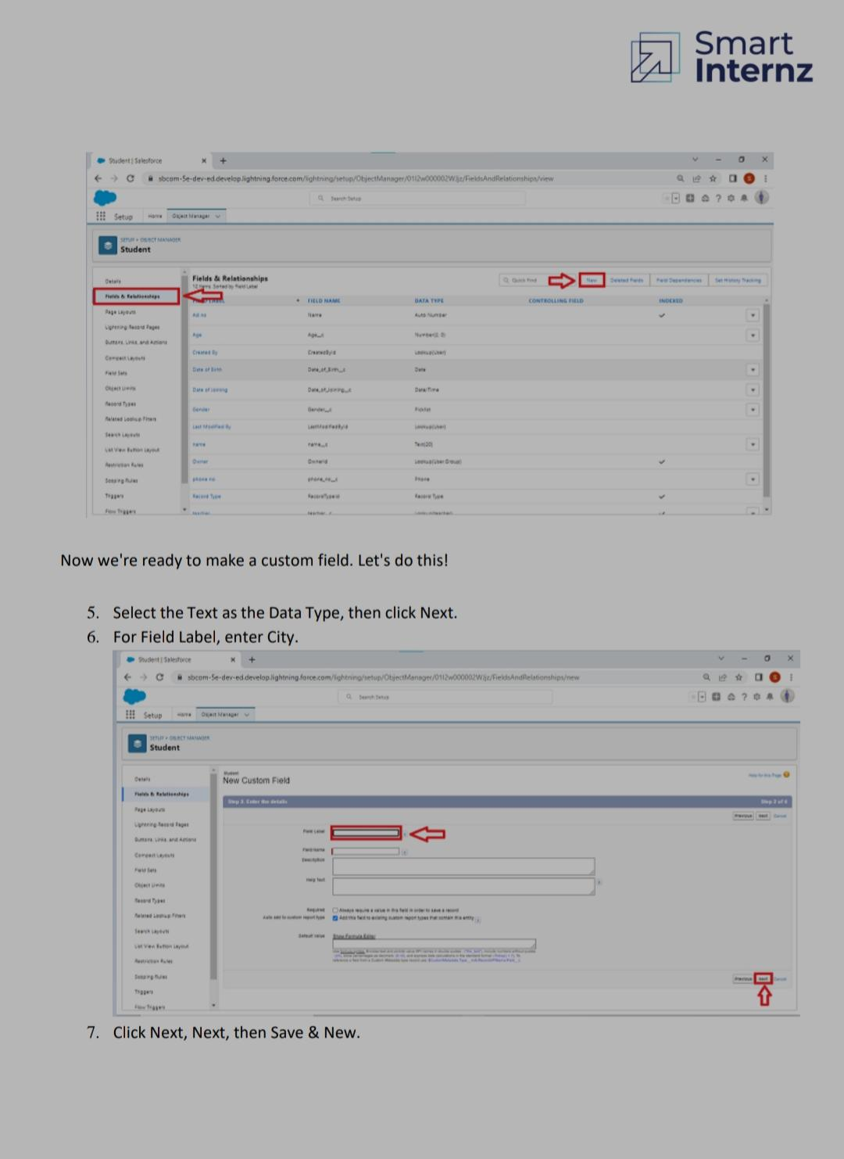
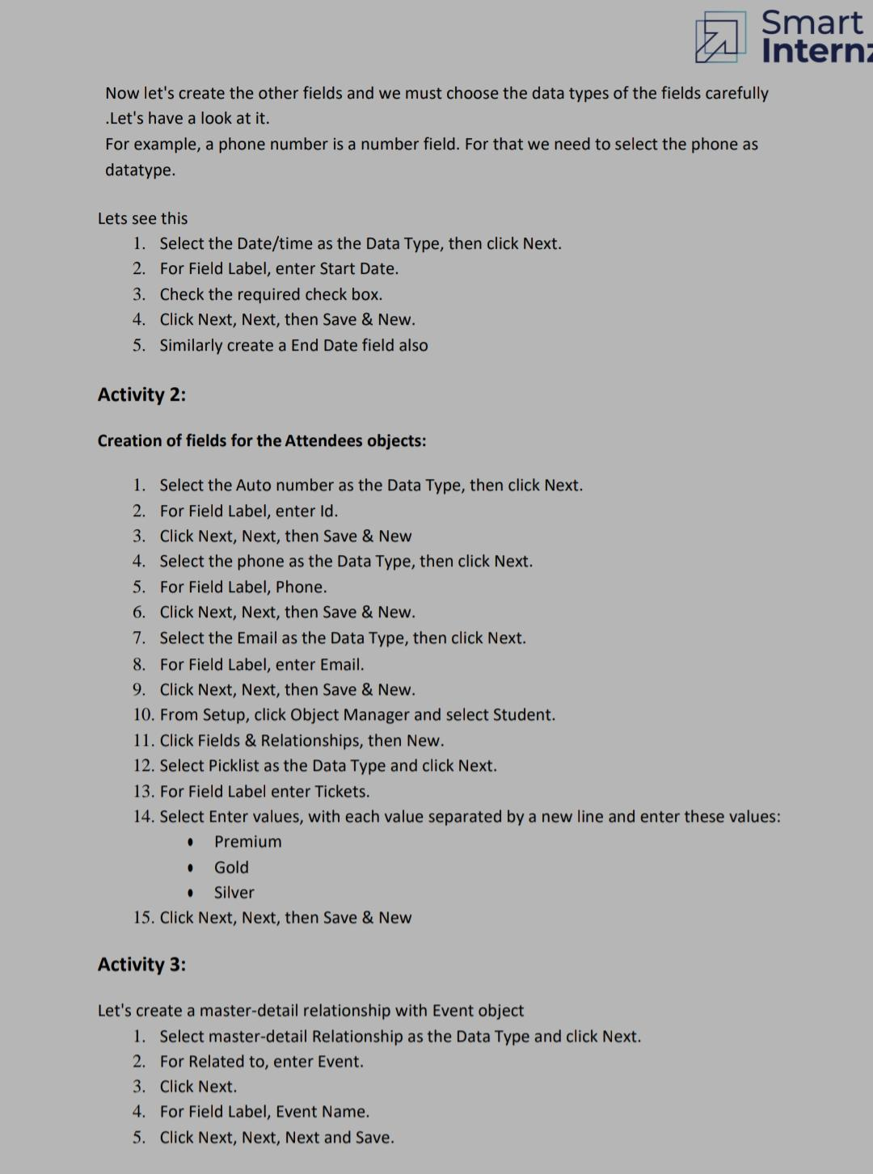
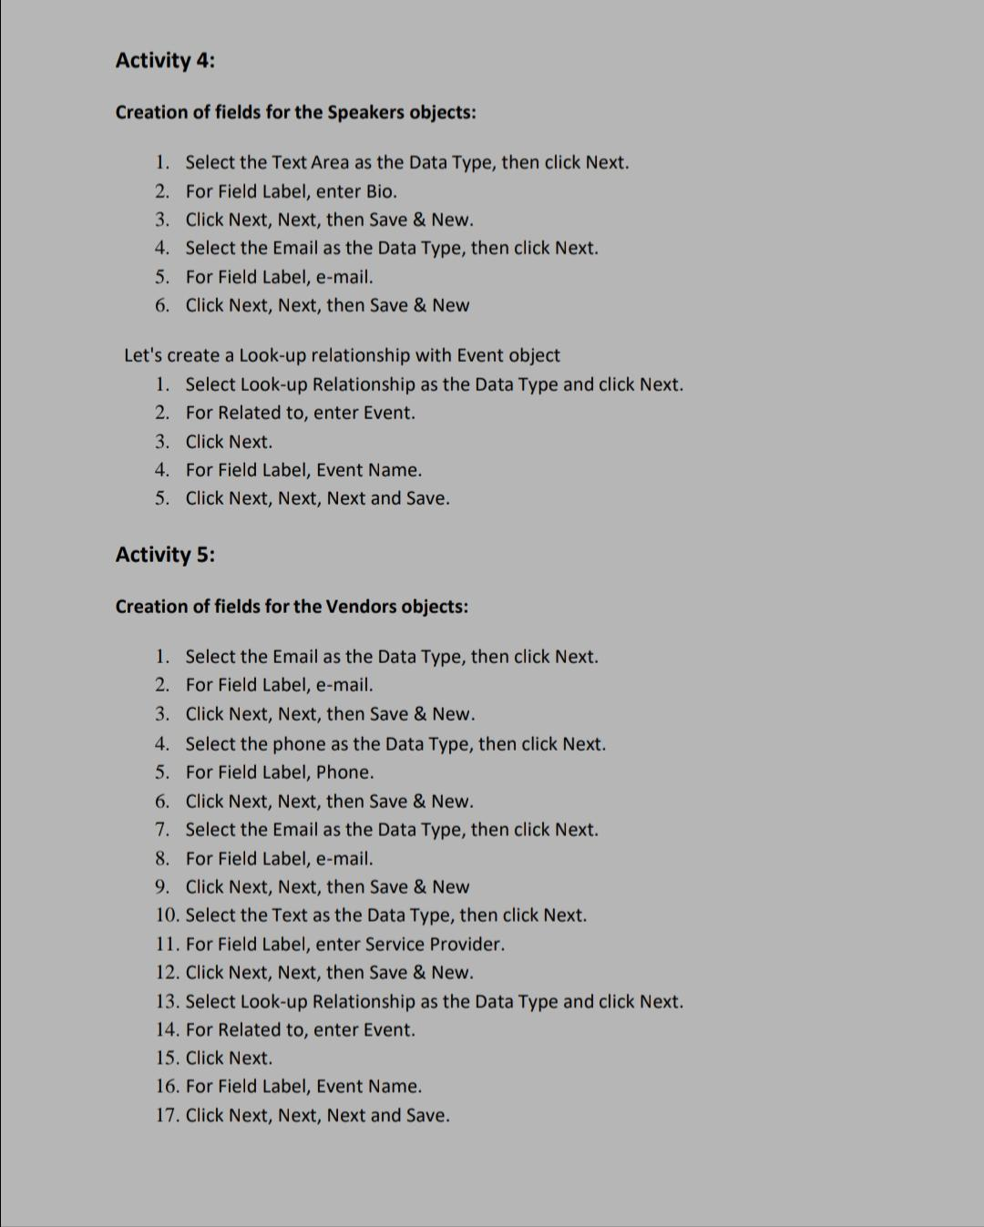
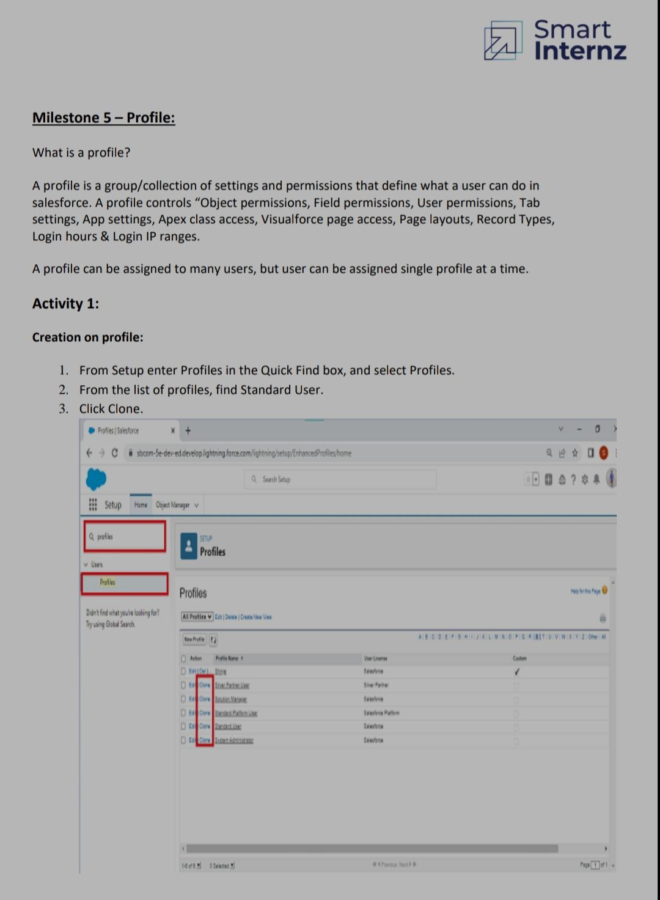
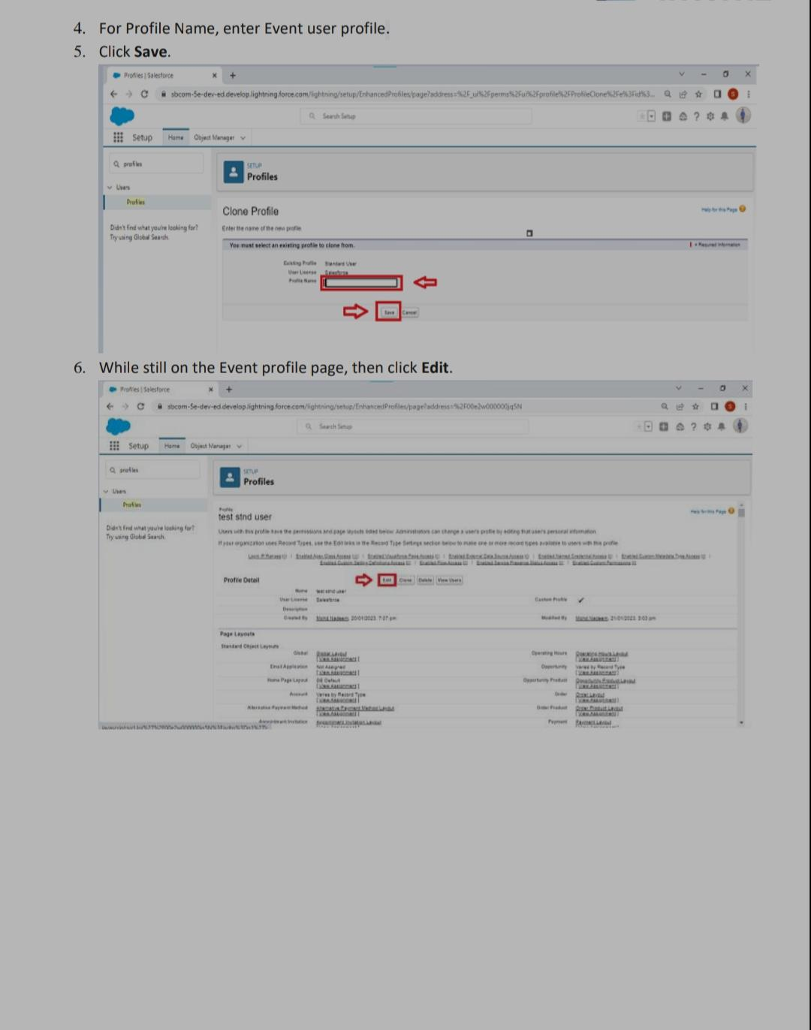
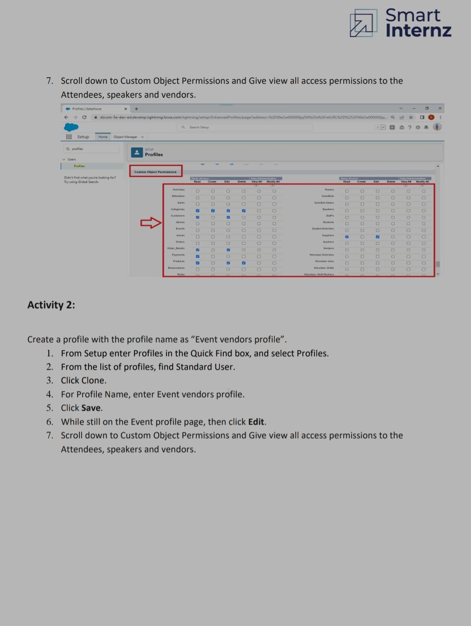
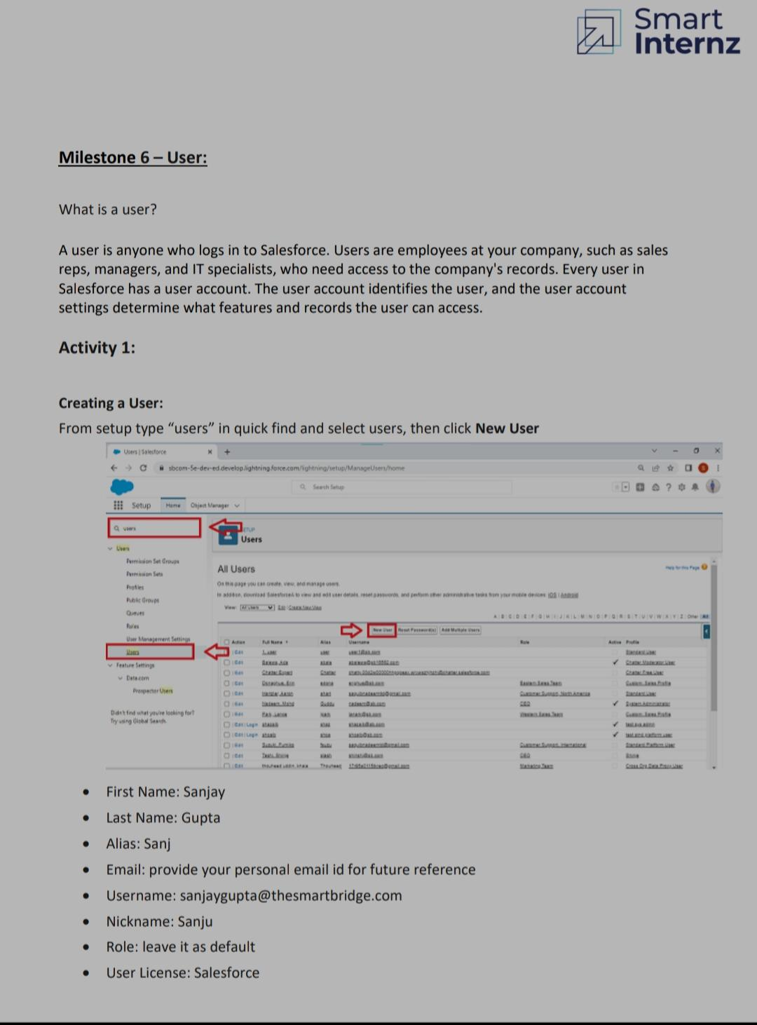
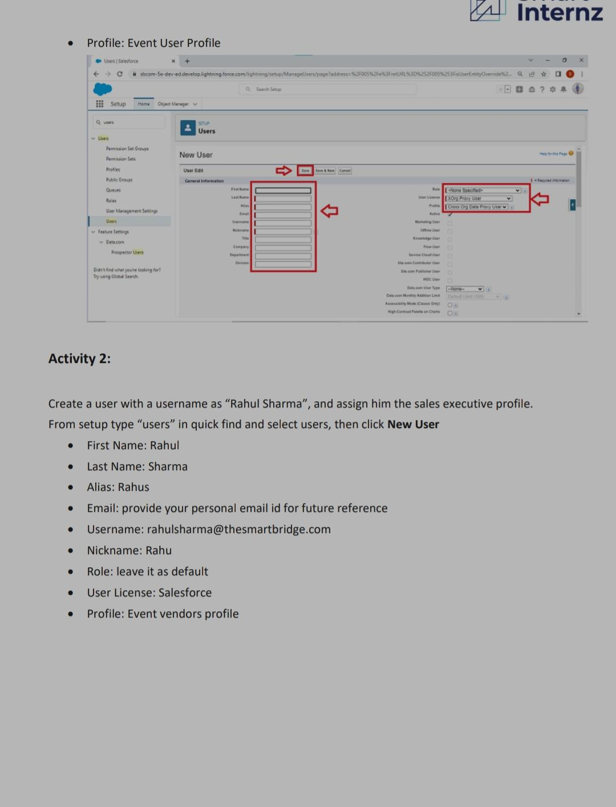
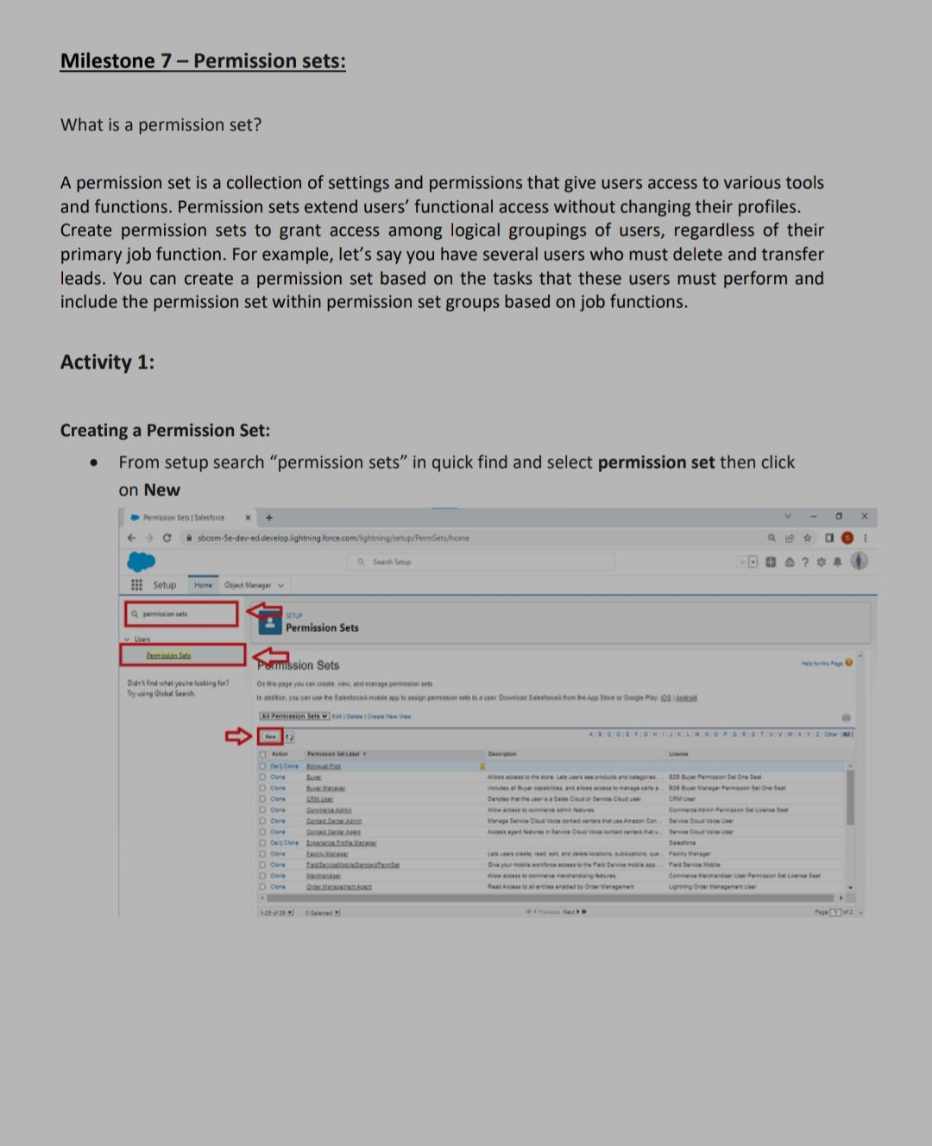

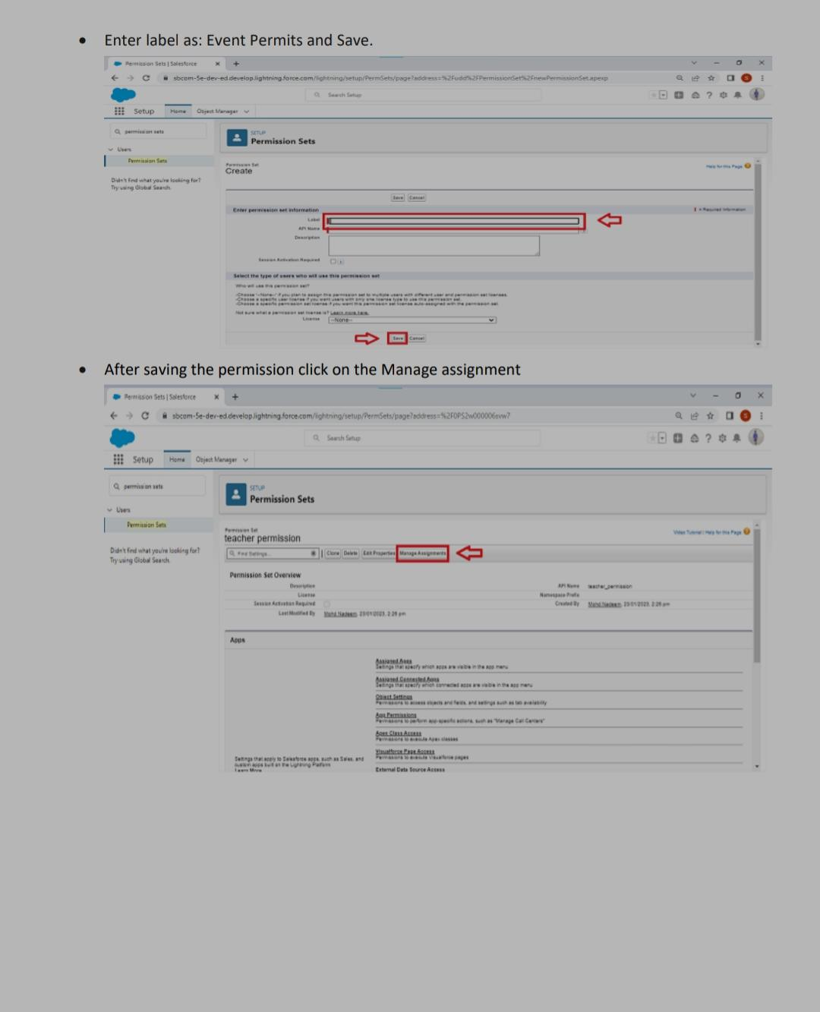

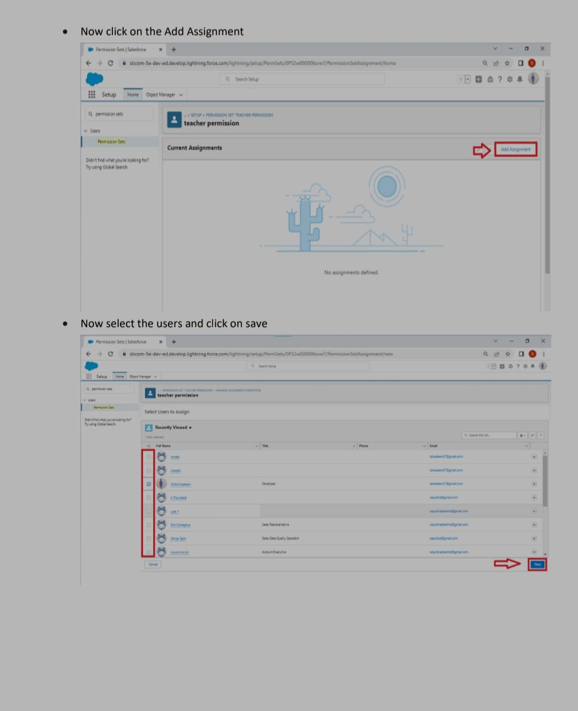

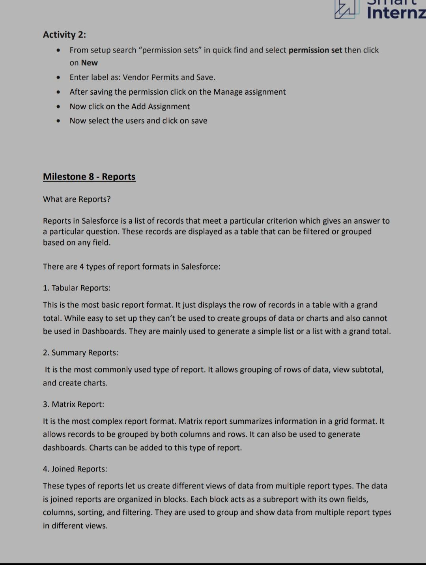

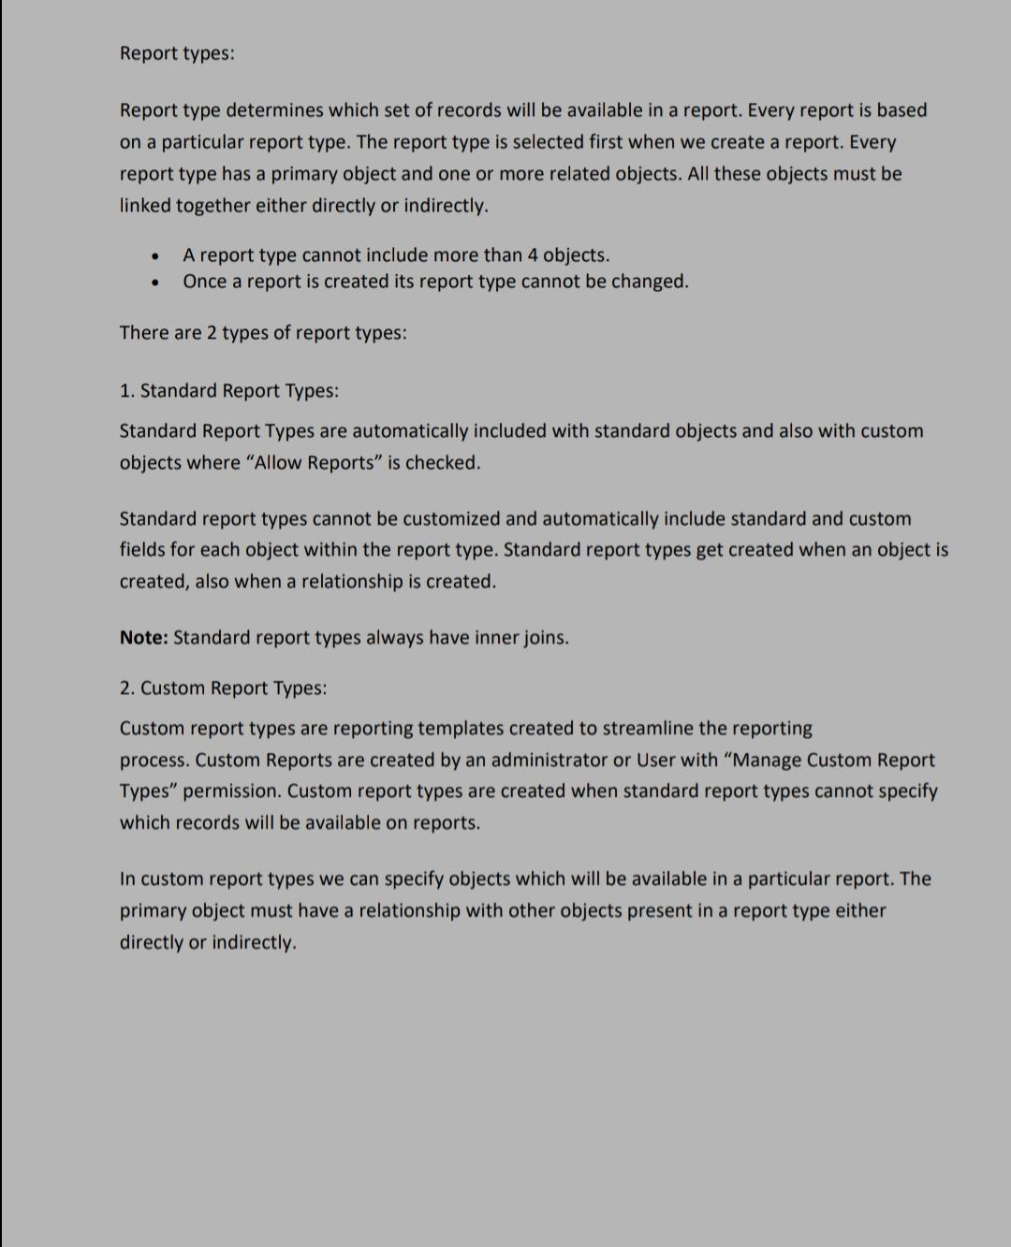
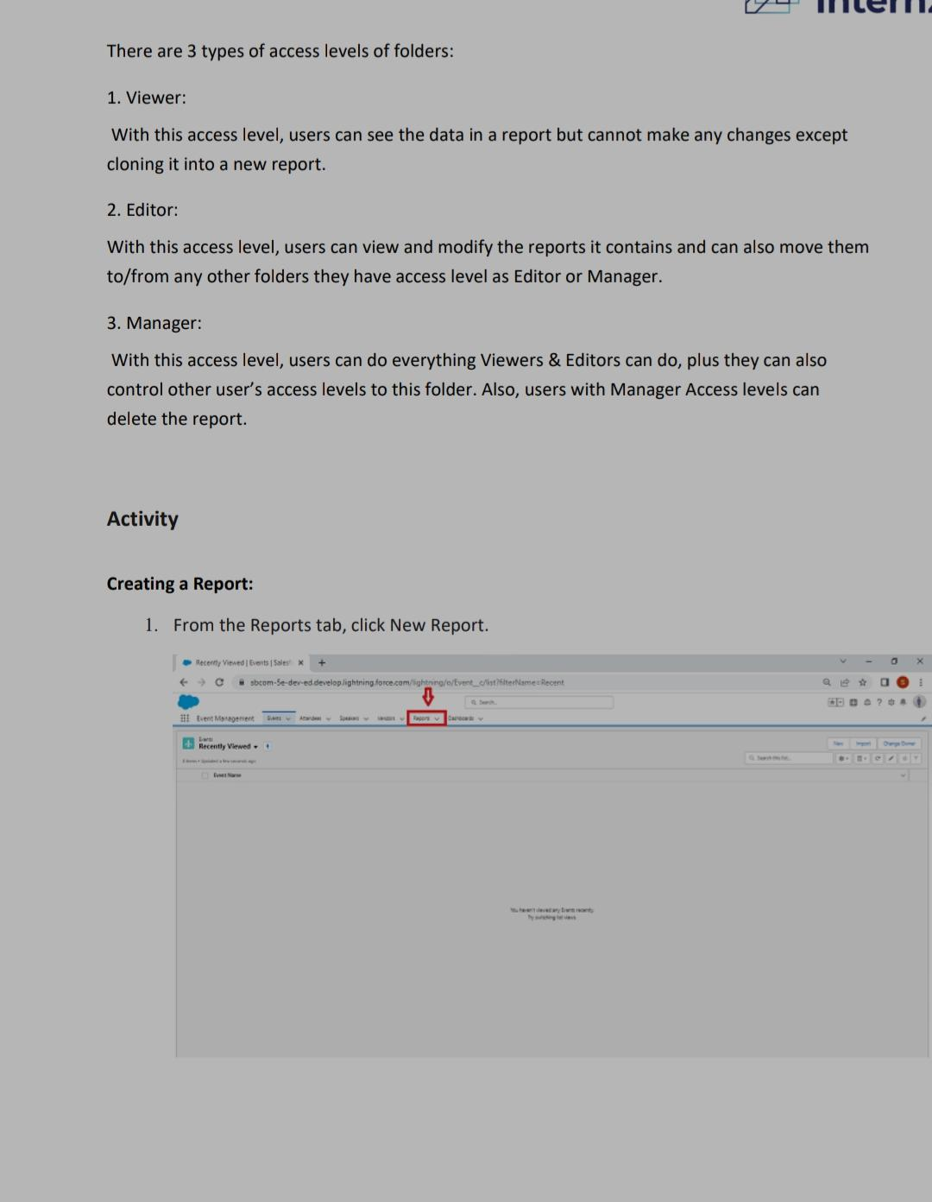
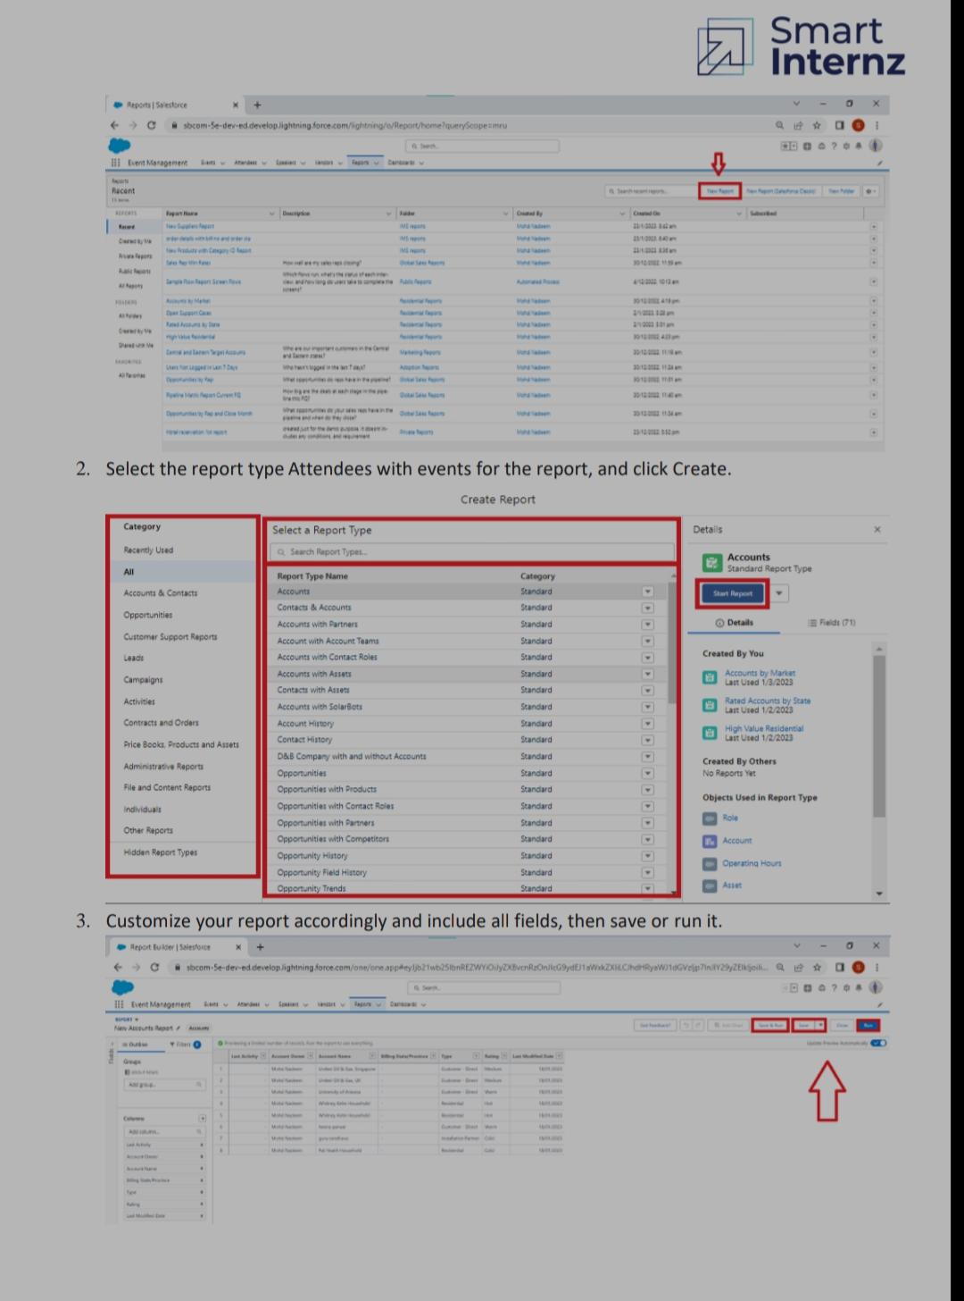
5.TRAILHEAD PROFILES PUBLIC URL:
Team leader - https://trailblazer.me/id/nnarmatha3
Team member 1:https://trailblazer.me/id/rangr13
Team member 2:http://trailblazer.me/id/pavim50
Team member 3:http://trailblazer.me/id/rrajeshwari7

ADVANTAGE OF EVENT MANAGER:
- Reduce administration workload
- Maximize flexibility
- Opportunities for creativity
- Ability to work on different events
- Chance to work with diverse clients
- Access in-depth reports and analytics
- Few educational requirements
- Collaborate work environment
- High projection for job growth
- Save time planning events.

DISADVANTAGE OF EVENT MANAGER:
- Unconventional work hours
- Time away from family and friends
- Experience requirements
- Job instability
- Multiple events at the same time
- High level of responsibility
- Security and privacy issues
- Time-consuming
- Feedback and complaint

FEATURES OF EVENT MANAGEMENT:
- The process of planning and Coordinating the event is usually referred to as event planning and which can include budgeting, scheduling, site selection,acquiring necessary permits, coordinating transportation and parking, arranging for speakers or entertainers,arranging sector, event security and catering.
- Customized processes & scheduling.
- Effortless event updates & tracking.
- Resources & documentation.
- Mobile on- the- go access.
- Hardware & software integrations.
- Date security & management.
- Custom reporting & dashboards.

PURPOSE OF EVENT MANAGEMENT:
- An event management system helps organizers plan, execute and report on events driving success for their business.
- Purpose to manage events throughout their lifecycle is the purpose of event management.

CONCLUSION:
Event Management System is user friendly and cost effective system, it is customized with activities related to event management Life-cycle.
It provides a new edge to management industry. Solution dot always keep your objectives and goals on top priority while developing any plan of work.

